**Ideation Phase**

**Define the Problem Statements**

|  |  |
| --- | --- |
| Date | 26 June 2025 |
| Team ID | LTVIP2025TMID59619 |
| Project Name | Shopez : one-stop shop for online purchases |
| Maximum Marks | 2 Marks |

**Customer Problem Statement Template:**

**To define the core problems online shoppers face while discovering and purchasing products, and use those insights to guide the development of Shopez.**

**I am :** an online shopper looking for a seamless and trustworthy shopping experience,  
**I’m trying to :** discover and purchase quality products quickly and confidently,  
**But** : most e-commerce platforms are cluttered, lack personalization, and have unreliable product reviews or sellers,  
**Because :** they prioritize volume over relevance and don’t effectively filter or verify listings,  
**Which makes me feel :** overwhelmed, unsure about my purchase decisions, and frustrated by wasted time.

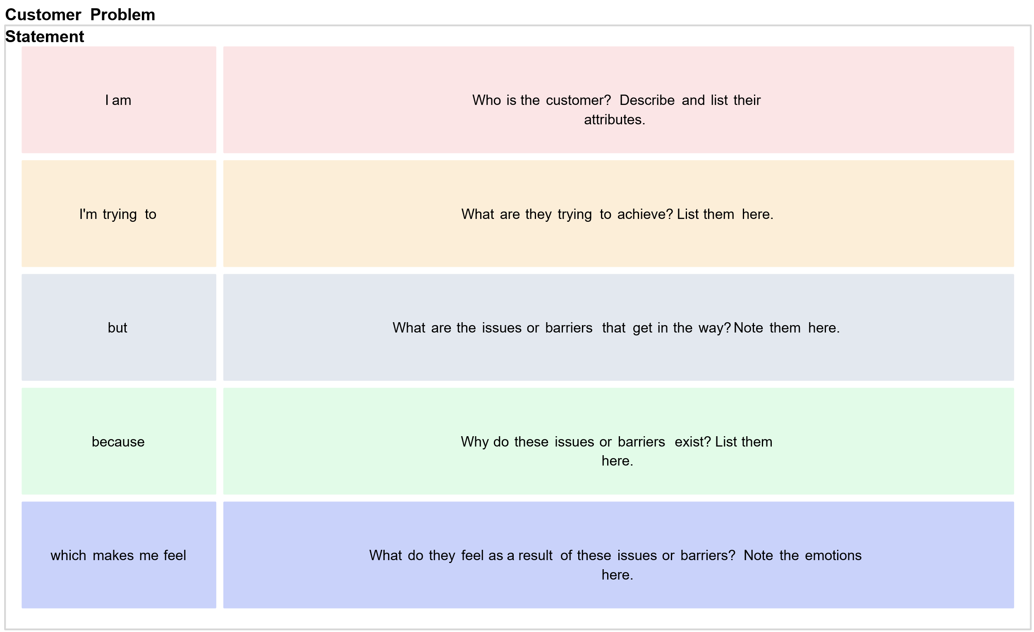

Reference: <https://miro.com/templates/customer-problem-statement/>

**Example:**

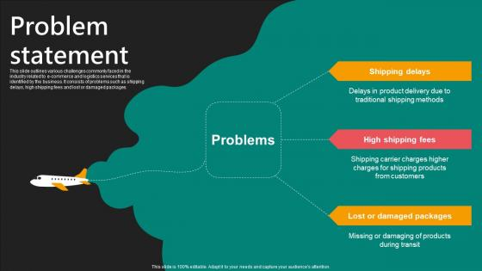

|  |  |  |  |  |  |
| --- | --- | --- | --- | --- | --- |
| **Problem Statement (PS)** | **I am (Customer)** | **I’m trying to** | **But** | **Because** | **Which makes me feel** |
| PS-1 | An online shopper looking for affordable, quality products | Discover trustworthy sellers and good deals easily | Most platforms show irrelevant or overwhelming product options | Their recommendation engines prioritize paid ads over customer interests | Frustrated, unsure about choices, and worried about wasting money |
| PS-2 | A small business owner trying to sell online | Attract customers and manage my store efficiently | Existing platforms are either too expensive or too complex to use performance | I lack technical knowledge and can't afford high listing fees or ads | Discouraged, left behind, and uncertain about growing my business online |